NEWSWEEK

ENDANGERED BLUE WHALES SPOTTED OFF NEW ENGLAND COAST
BY ARISTOS GEORGIOU ON 2/27/20 AT 6:15 AM EST
Researchers have spotted a pair of endangered blue whales—the largest animals on Earth—in the waters off the coast of New England.
Orla O'Brien and Amy Warren from the New England Aquarium were conducting a survey of marine life in the Northeast Canyons and Seamounts Marine National Monument when they observed the cetaceans, WHDH reported.
This large protected area is roughly the size of Connecticut and is located around 130 miles southeast of Cape Cod, Massachusetts.
Scientists Record Conversations of Mysterious Dolphin

"Blue whales have been sighted infrequently in the area over the past decade: twice in the
area that is now the marine monument, and six or so sightings in similar areas of the Atlantic, so it is an uncommon sighting," O'Brien, an assistant scientist at the New England Aquarium's Anderson Cabot Center for Ocean Life, told Newsweek.s by scrollerads.com
"It's the first time that the New England Aquarium has seen blue whales while conducting aerial surveys in the monument. However, this survey is the first one that we have flown in the monument in the winter. We are curious about whether we will see blue whales on future winter surveys," she said.
In total, researchers Orla O'Brien and Amy Warren spotted 322 whales and dolphins of different species during the six-hour long survey.
Among the animals the team observed were a group of 50 bottlenose dolphins and striped dolphins, as well as sperm, pilot, fin, sei, humpback and Sowerby's beaked whales.
"The marine monument is such an important area," O'Brien said in a press release. "It plays a critical role in the life history of so many species of whales and dolphins that come here with their calves to find food. As marine mammal researchers, it's such a thrill to fly in this area and see such a great diversity of animals."
The National Monument contains two distinct areas: one which includes three underwater canyons and another that covers four seamounts—submerged mountains formed by volcanic activity.
According to the team, one of the blue whales was seen directly above the Oceanographer Canyon—which is the deepest canyon in the National Monument, extending downwards for around 4,000 feet. This observation could be important for our understanding of blue whales in the region.
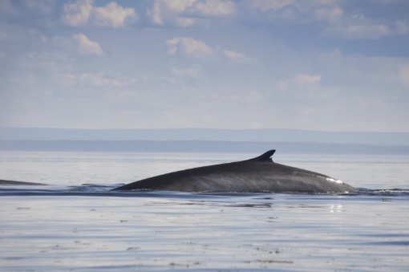Stock photo: A blue whale in the North Atlantic Ocean.ISTOCK
"While blue whales are known to frequent areas where deep canyons intersect with continental shelf edges, this sighting was important because the blue whale population in the Northwest Atlantic is thought to be only around 250 animals," a spokesperson for the aquarium said in a press release.
Blue whales are the largest animals ever to live on the planet, growing up to about 110 feet and weighing more than 330,000 pounds in the Antarctic, according to the National Oceanic and Atmospheric Administration.
They are found in all the world's oceans except the Arctic, usually swimming alone, in pairs, or sometimes even in small groups. Today, blue whales are considered endangered across their global range and, although the worldwide population is unknown, it is thought to be in region of 10,000 to 25,000 individuals.
The global population used to be much higher—perhaps around 300,000—however, commercial whaling which began in the early 1900s decimated their numbers. Nevertheless, researchers think that the global population is currently growing.
This article was updated to include additional comments from Orla O'Brien.

CTPost

Rare blue whales spotted 130 miles east of Connecticut
By Jordan Fenster
Updated 7:04 am EST, Thursday, February 27, 2020
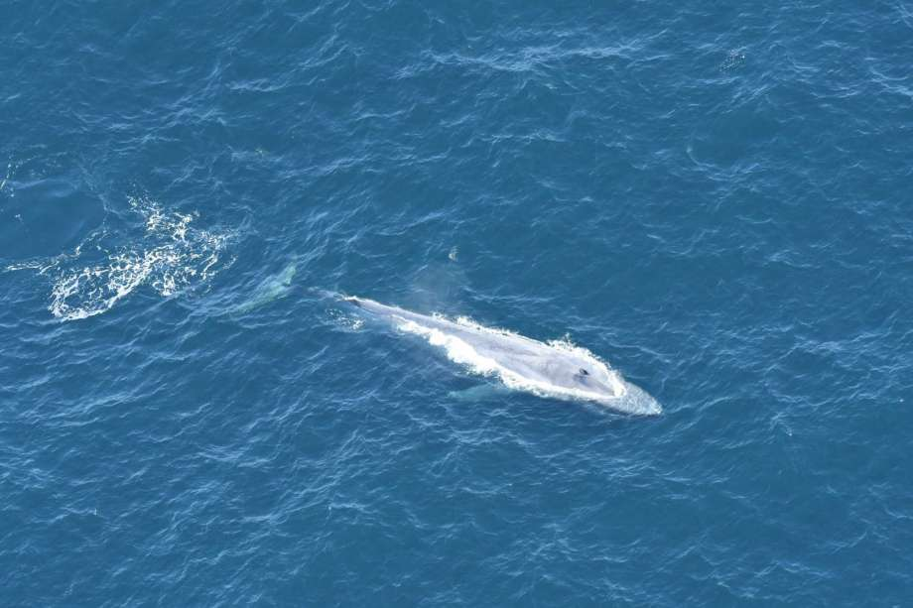
Photo: New England Aquarium
One of the whales spotted February, 2020 in the deep Atlantic ocean east of Connecticut.
Blue whales have been spotted in the Atlantic Ocean east of the Connecticut shoreline.
This month, researchers from the New England Aquarium surveyed the Northeast Canyons and Seamounts Marine National Monument about 130 miles southeast of Cape Cod, according to a release from the aquarium
Within six hours, the researchers had counted 322 whales and dolphins, including two blue whales.
“As marine mammal researchers, it’s such a thrill to fly in this area and see such a great diversity of animals,” researcher Orla O’Brien said in a release.
The National Oceanic and Atmospheric Association lists blue whales as endangered. The exact population size is not known, but there were only 440 confirmed sightings in the Atlantic Ocean between 1979 and 2009.
According to current estimates, there may be as few as 250 individual blue whales left in the Atlantic.
According to NOAA, “Blue whales are the largest animals ever to live on our planet.”
The Northeast Canyons and Seamounts National Monument consists of approximately 4,913 square miles, about the size of Connecticut.
In addition to the blue whales, the team documented pilot, fin, sei, humpback, sperm, and Sowerby’s beaked whales.

